**Practical Task 1**

1. Locate and follow the HyperionDev company page. Take a screenshot to show you have done this and paste it into your Google doc.

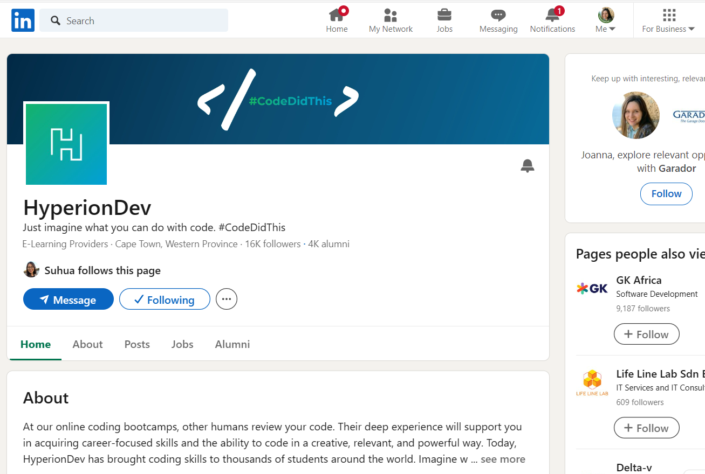

1. Add the bootcamp that you are completing with HyperionDev under your education section. Take a screenshot to show youhave done this and paste it into your Google doc.

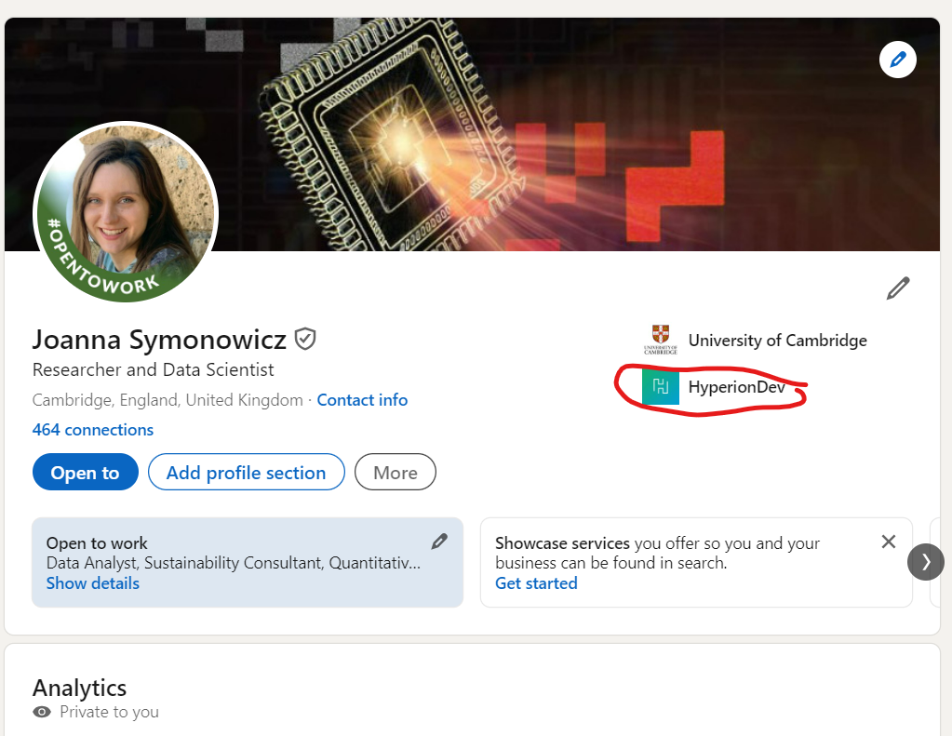

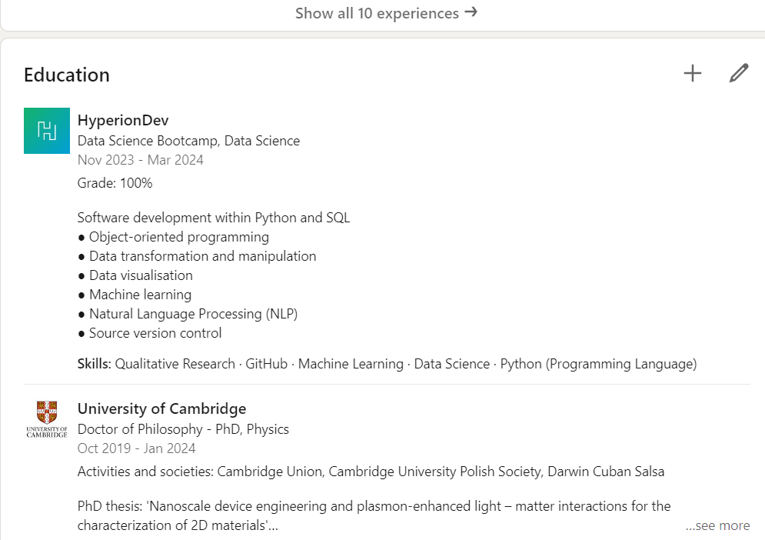

1. Once you are happy with your LinkedIn setup, put the link to your profile on your CV.

Done, my LinkedIn: <https://www.linkedin.com/in/joanna-symonowicz-b980b9159/>

**Practical Task 3**

**JOB SEEKERS**

Find 5 junior tech roles currently being advertised. (…) For each of the roles you have identified, again identify the recruiting or hiring managers and their contact details.

Job 1: Risk Model Developer

* URL: <https://www.workingatdllgroup.com/en/Vacancy?id=B262EA5EC18F4B71A527A1B280BA254C>
* Location: remote
* Company: DLL
* Company size: 5,001-10,000 employees
* Hiring person: Natascha Aerts-Hooi
  + LinkedIn: <https://www.linkedin.com/in/nataschahooi/>
  + e-mail: [Natascha.hooi@dllgroup.com](mailto:Natascha.hooi@dllgroup.com)

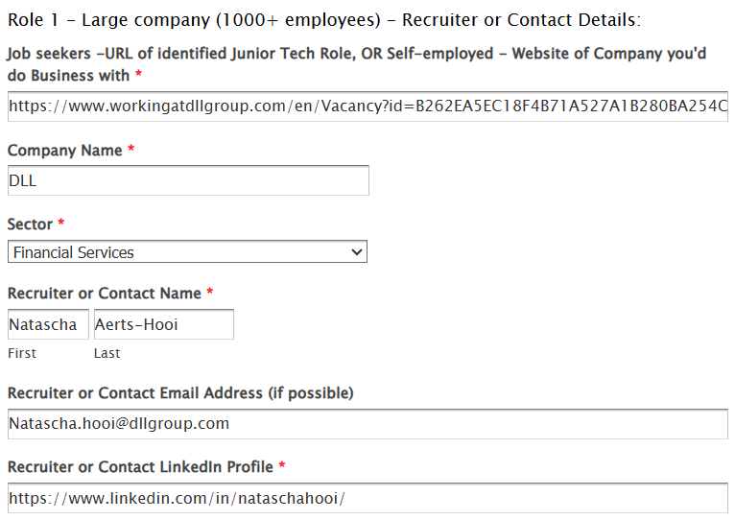

Job 2: Quantitative Developer, Macro

* URL: <https://www.worldquant.com/career-listing/?id=4304495006&source=c8fd37dd6us>
* Location: London
* Company: QuantWorld
* Company size: 501-1000 employees
* Hiring person: Dorottya Nagy
  + LinkedIn: <https://www.linkedin.com/in/dorottya-nagy-485b5154/>
  + e-mail: [info@WorldQuant.com](mailto:info@WorldQuant.com)

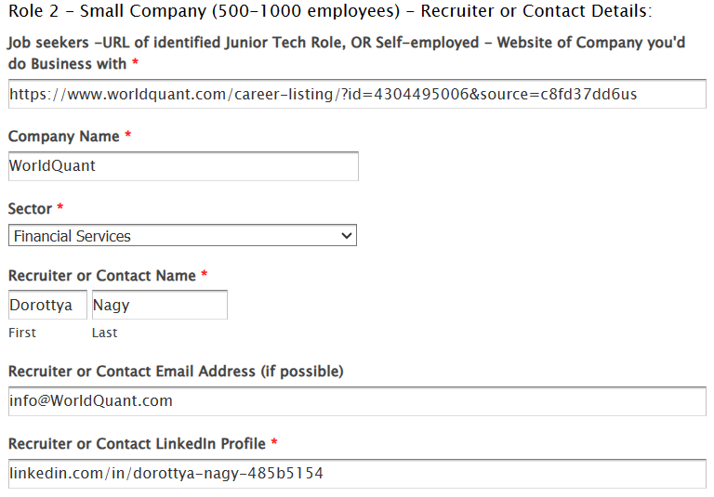

Job 3: Climate Data Scientist

* URL: <https://climateaistage.wpengine.com/careers/?id=4082771007>
* Location: remote
* Company: ClimateAi
* Company size: 51-100 employees
* Hiring person: Katie Dean (Morrissey)
  + LinkedIn: <https://www.linkedin.com/in/katiemorrissey/>

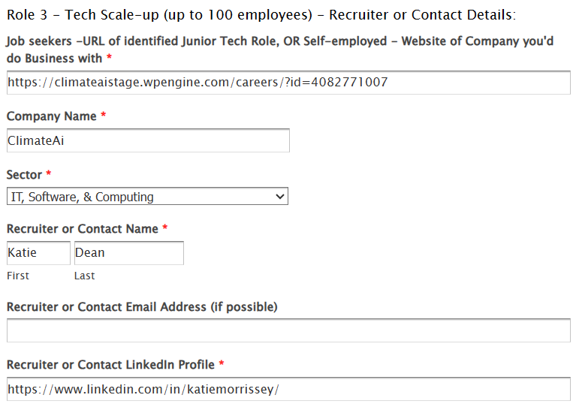

Job 4: QUANTITATIVE RESEARCHER - INTERN

* URL: <https://careers.point72.com/CSJobDetail?jobName=quantitative-researcher-intern&jobCode=CSS-0000570&retURL=/CSCareerSearch>
* Location: London
* Company: Point72
* Company size: 1,001-5,000 employees
* Hiring person: Grace Donaldson
  + LinkedIn: [linkedin.com/in/grace-donaldson-023013108](https://www.linkedin.com/in/grace-donaldson-023013108)

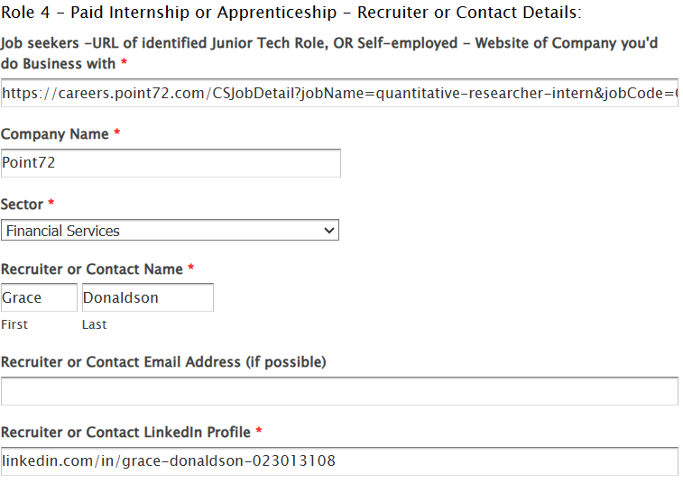

Job 5: Quantitative Developer - New Trading Pod - Systematic Hedge Fund

* URL: <https://www.linkedin.com/jobs/view/3791275873/?alternateChannel=search&refId=XOh%2BShEFGPB8o9TdjIXXQA%3D%3D&trackingId=Xio2oqrlC4q3Vb4YKdKdsQ%3D%3D>
* Location: London
* Company: Capital Markets Recruitment
* Company size: 11-50 employees
* Hiring person: Rhys Nugent
  + LinkedIn: [linkedin.com/in/rhys-nugent-36a66220b](https://www.linkedin.com/in/rhys-nugent-36a66220b)
  + e-mail: [rhys.nugent@capitalmarkets.ie](mailto:rhys.nugent@capitalmarkets.ie)

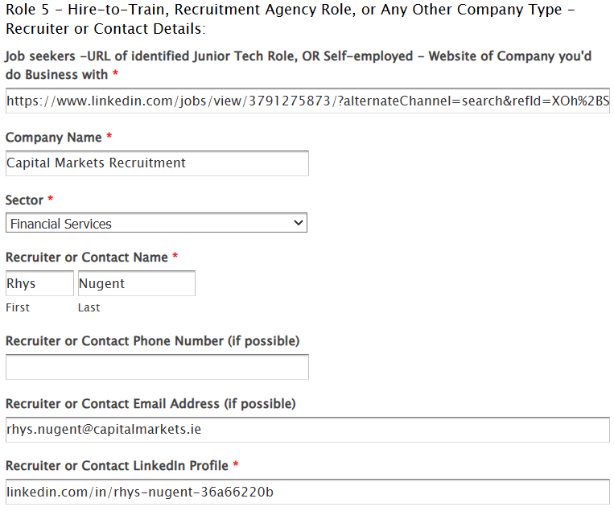

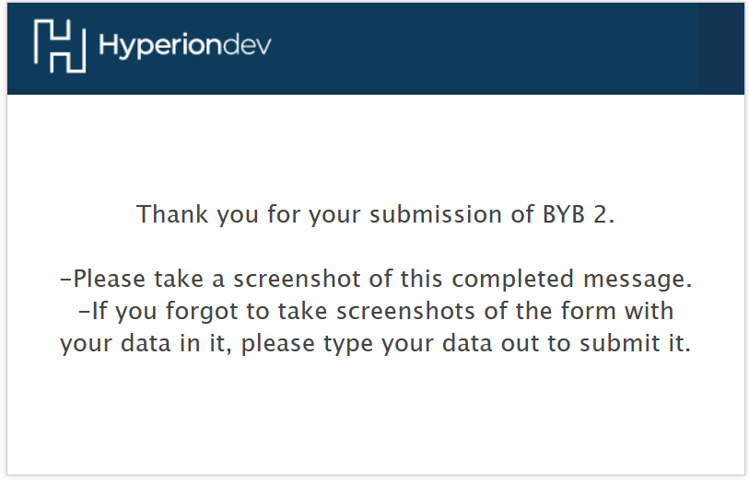

2. My public link to your Job Interviews/Pitch Opportunities tracker: <https://docs.google.com/spreadsheets/d/12TX9iYbzYEnn4uMH0XC7RVWj6YGCPJVm0QRKc4j-L4I/edit?usp=sharing>